**Assignment 19.1:**

**Problem Statement:**

1. What is the total number of gold medal winners every year?
2. How many silver medals have been won by USA in each sport?

**Starting spark-shell:**

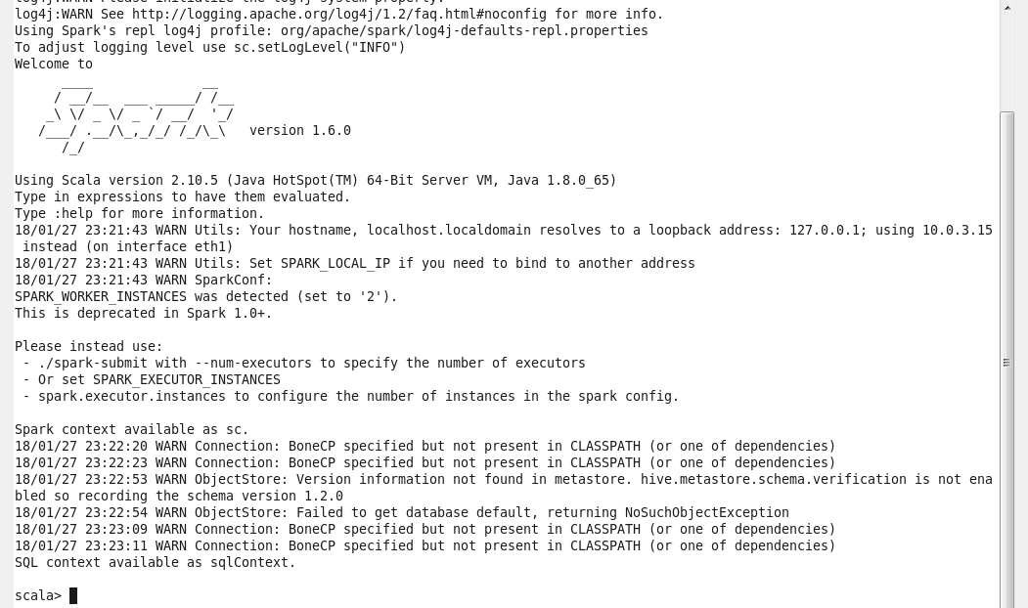

Create RDD with the imported file data:



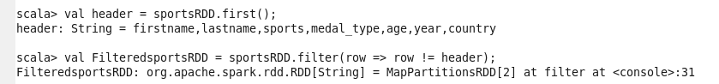

Loading table data in to dataframe and Register the data frame with temporary table

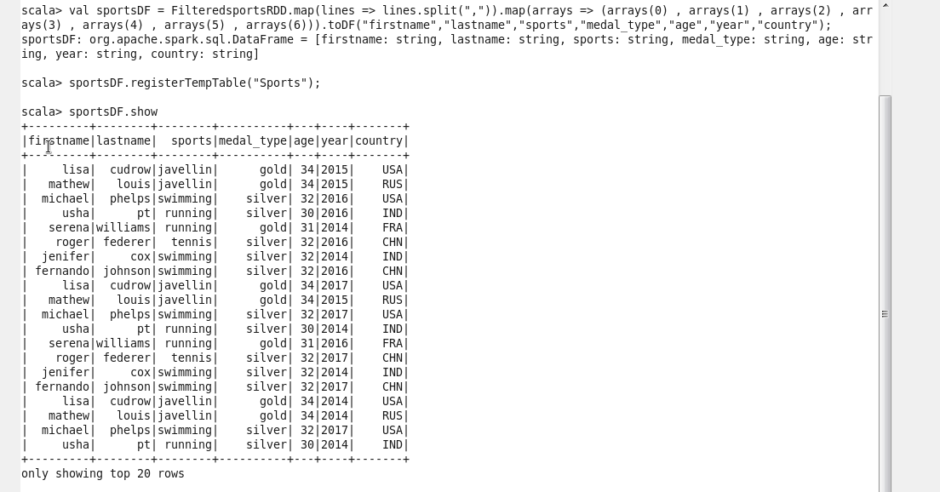

1. What is the total number of gold medal winners every year?

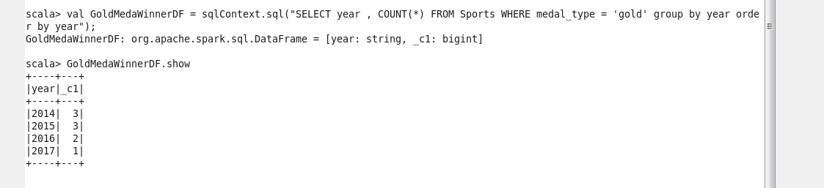

1. How many silver medals have been won by USA in each sport

